

Requirement Document

SDEV 265



September 2, 2022

Ivy tech Community college

Table of Contents

Introduction 2

User Requirements Definition 3

System Architecture 4

System Evolution 5

Appendices 6

Systems Development Life Cycle 7

# Introduction

Our team launches a Java-based meal-prepping website. The developers will create and maintain the integrity of the website. This site is a meal schedular database for end-user and administration. Subscribers can view, create, and plan for grocery store visits and daily meal preparations. The accesses administrators can view the behaviors of subscribers on the website; This includes the users' log-in dates and times, usernames, email addresses, positions, searched pages, updated recipes, selected recipes, and the number of created user- lists.

# User Requirements Definition

This section should identify all requirements that the team plans on implementing within the software project

Our priority list is on a scale from 1-3. One is the highest priority, three is the lowest. Any item noted with a 0 is a stretch goal

|  |  |  |
| --- | --- | --- |
| Item | Priority | Member Responsible |
| Design Web Page | 1 | Torri |
| Convert Prototype to Web Accessible | 1 | Iri |
| Website Prototype | 1 | Torri |
| Finalizing Documentation | 1 | Kirsten |
| Recipe Curation/Research | 2 | Kirsten |
| Add Developed Web Page | 2 | Torri |
| Create Login | 2 | Iri |
| Tiered Login (admin/ customer) | 3 | Iri |
| Update Web Prototype | 3 | Torri |
| Update GUI Prototype | 3 | Iri |
| Polish Web Development | 0 | Torri |
| Polish GUI | 0 | Iri |
| Additional Recipes | 0 | Kirsten |
| User Management Database | 0 | Torri/ Iri/ Kirsten |
| Recipe Database | 0 | Torri/ Iri/ Kirsten |
| Site Visitations | 0 | Kirsten |

Meal planning website:

* Breakfast, lunch, and dinner options
* Java and Web-based design
* User will log in, select how many days and which type of meals (breakfast, lunch, or dinner) from a dropdown menu and be taken to a curated list of menu ideas and recipes.
* There will also be random meal generators that will show various additional recipes via a photo of the meal.
* This site will itemize the groceries needed for each meal and place them into categories like “Kitchen Staples” (what people typically already own) and “Shopping List" (specialized ingredients).
* Additional recipes can also be searched via keyword, such as “beef”, or a dropdown menu of categories, such as “vegan”.
* User will be able to fill out their information to go back to their curated lists.

# System Architecture

Click the link for a bigger image of the picture below: Java- Architecture

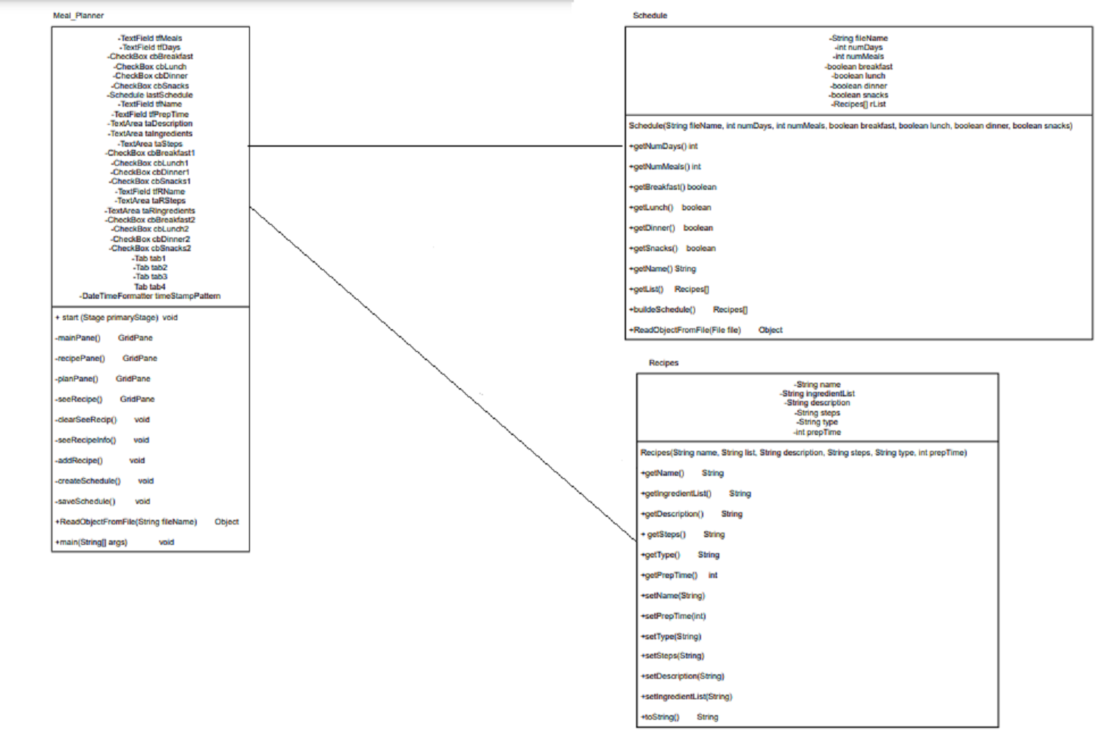

# 

# System Evolution

Our system begins with a basic website developed with Java code. It will create meals for a user and display photos as well as recipes and ingredients needed for each meal. This will be accessible once the user inputs how many days of meal prep that they are looking to create. From there, our system plans to implement a login function so that existing users will be able to access their information once they log in. We are beginning with a set number of meals for each type of meal, but this can be upgraded with a more extensive library of recipes and food types.

# Appendices

* Iri has previously created a Java GUI project for meal prepping that will serve as the baseline for the idea.
* Torri has web development knowledge and will create a website for the program.
* Kirsten will curate the data and images to create recipes that are easy to understand and follow.
* Together, the java code and website development will work, in tandem, to create a user-friendly site.

# Systems Development Life Cycle

Our project will be implemented through hybridization of the waterfall technique while still maintaining agile methods. In the beginning, we are structuring an overall plan of development, as well as a timeline. From there, we will continuously meet throughout the semester to further enhance and adapt our project.

1. Planning

* We have created our idea as a group and plan to meet weekly to enhance our Meal Prep site.

1. Analysis

* In meetings we have come up with a plan of gathering what items we want to add in our website. There will be a login, curated list of recipes, and places for people to view other recipes as well.
* Fortes: We have a java program that is already running to use as a base. This will help us create the behind-the-scenes code to get our website running. Torri has web development experience and will be able to create a website with various recipes.
* Weak Points: We may have a limited availability of various recipes. We also have a more limited knowledge of database systems, which may lead to an inability to create sites for specific users that can be recalled at a later date. Overall, our goals are lofty for our final product, but we have assessed our priorities and will attempt to implement additional goals as we go.

1. Design

* Our program will run as a web-based program.
* Java code will be implemented in the background (potentially via JavaScript)

1. Implementation

* We have structured our implementation via a UML diagram as well as a priority “to-do” list (see above).
* Our site will be focused on user accessibility and catering to each person’s needs. It will be easy to navigate through pictures and an easy-to-understand format. We will implement testing through our group and peers to ensure we have accurate formatting.

1. Maintenance

* Our site is dedicated to a base scope of allowing users to access recipes and develop a menu plan.
* The goal is to further the design of our product, allowing the user to extend their calendars and prep further in advance.
* We can update our library of recipes and types of recipes.
* Another goal is to create an itemized list of ingredients a user may have in their home and what they need to shop for in the future.
* Overall, we will have a working base model and can only add more description and depth as we work.